AUTOMATIC CHANGE TRACKING

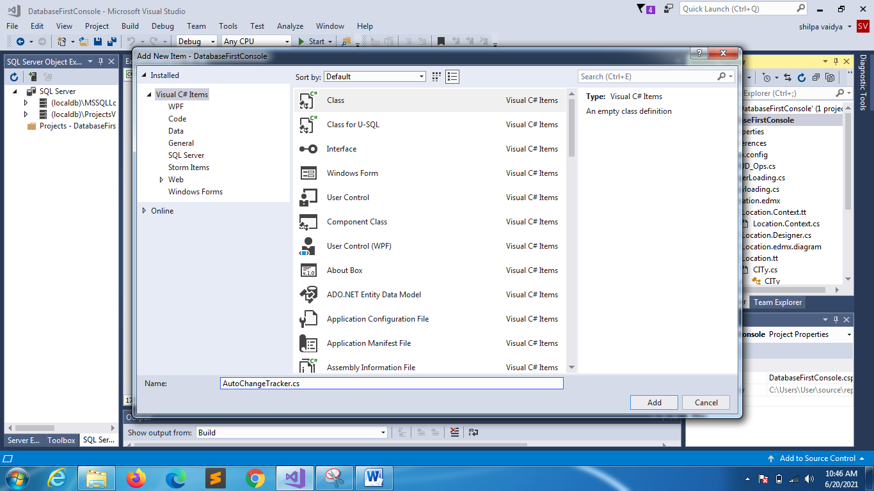

CHANGE STARTUP PROPERTIES

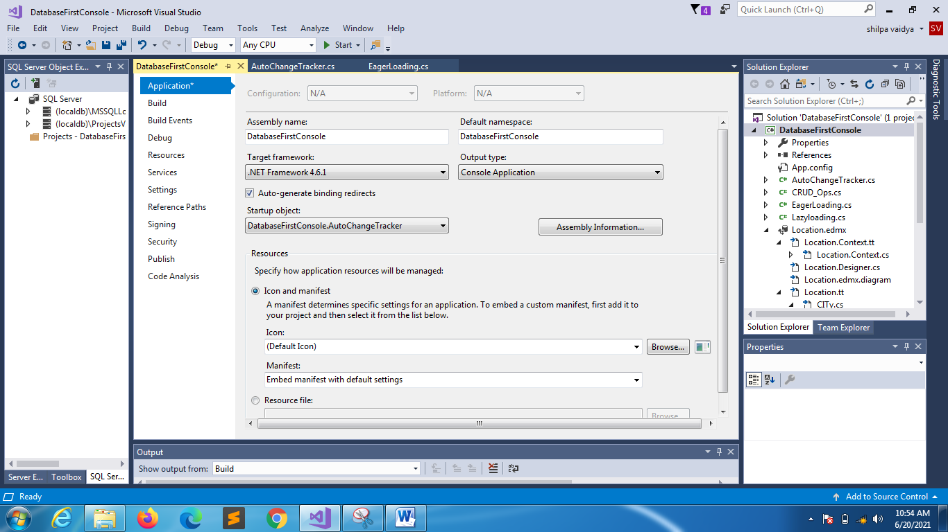

NOTE: WE ARE JUST NOTING THE CHANGE TRACKER NOT SAVING THE CHANGES(FOR DEMONSTRATION PURPOSE ONLY)

using System;

using System.Collections.Generic;

using System.Linq;

using System.Text;

using System.Threading.Tasks;

namespace DatabaseFirstConsole

{

class AutoChangeTracker

{

public static void Main(string[] args)

{

MyDbEntities db = new MyDbEntities();

DEPTLOC newloc = new DEPTLOC() { AREAID = 13, AREANAME = "JP Nagar", CITYID = 5, PHONE = 9865435678 };

db.DEPTLOCs.Add(newloc);

Console.WriteLine("After adding");

foreach (var tracker in db.ChangeTracker.Entries<DEPTLOC>())

{

Console.WriteLine( tracker.State);

}

DEPTLOC modifiedarea = db.DEPTLOCs.Find(34);

if(modifiedarea!=null)

{

modifiedarea.PHONE = 7878787878;

}

Console.WriteLine("After modifiction");

foreach (var tracker in db.ChangeTracker.Entries<DEPTLOC>())

{

Console.WriteLine(tracker.State);

}

DEPTLOC delarea = db.DEPTLOCs.Find(34);

if (delarea != null)

{

db.DEPTLOCs.Remove(delarea);

Console.WriteLine("After deletion");

foreach (var tracker in db.ChangeTracker.Entries<DEPTLOC>())

{

Console.WriteLine(tracker.State);

}

}

}

}

}